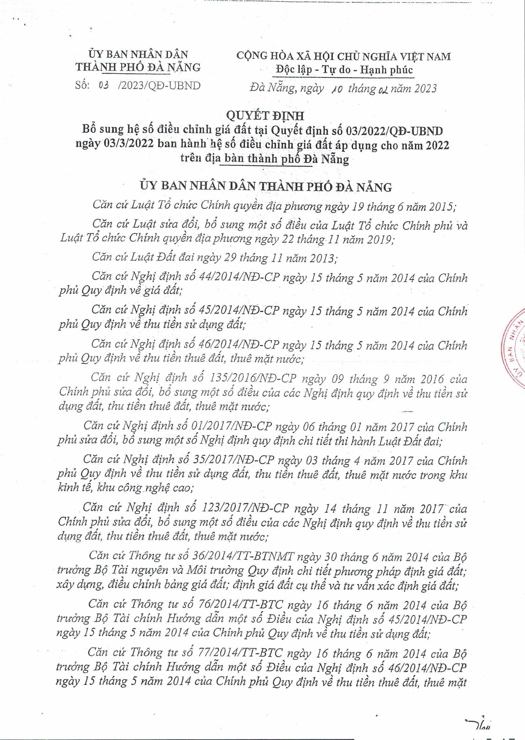
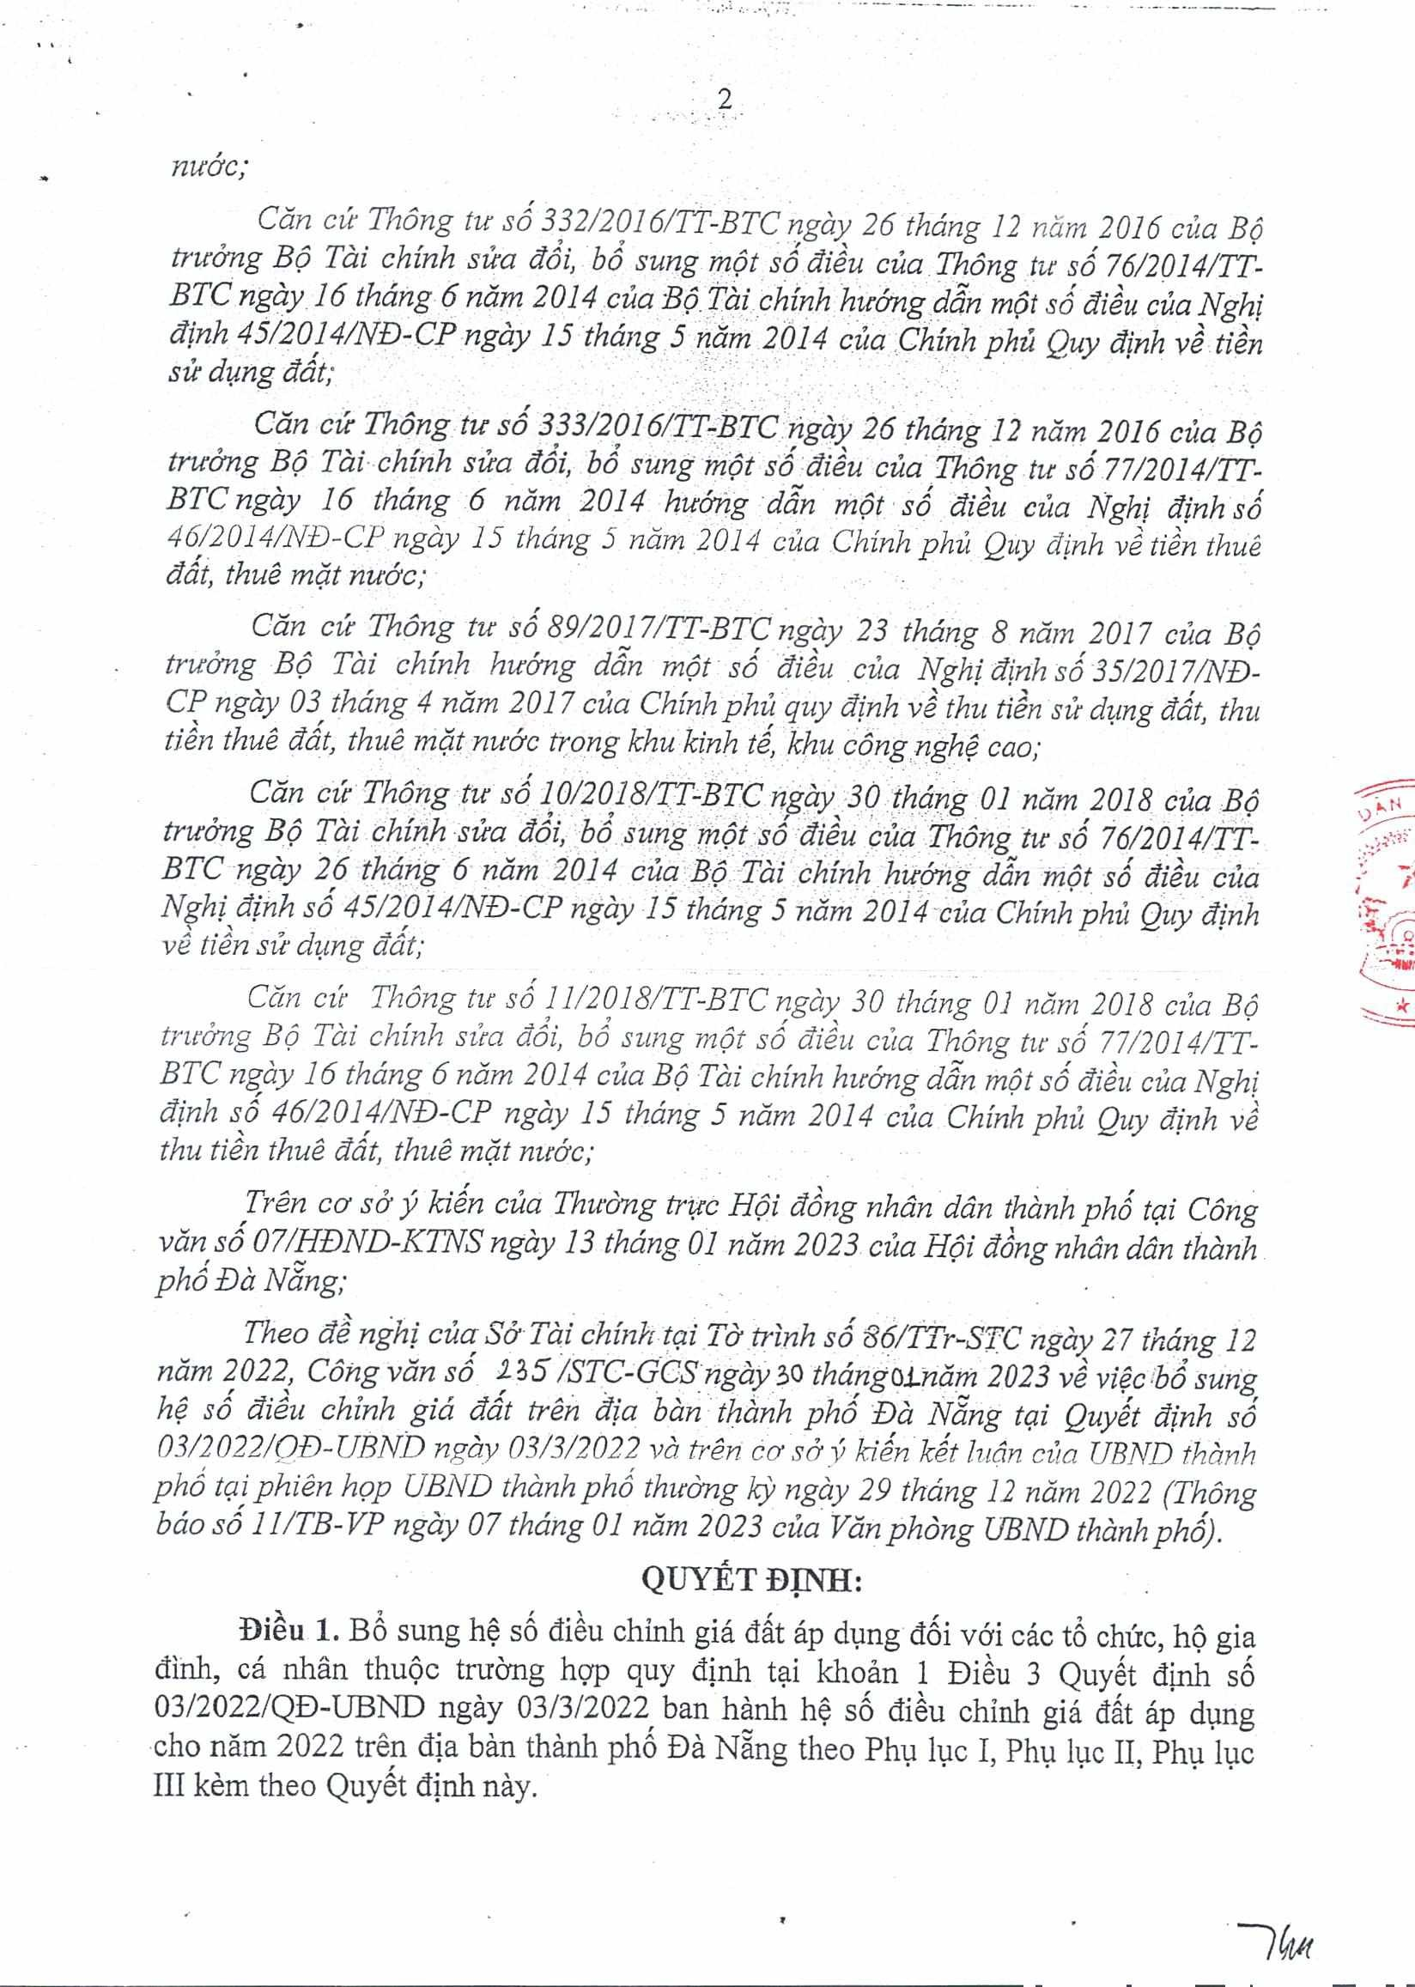
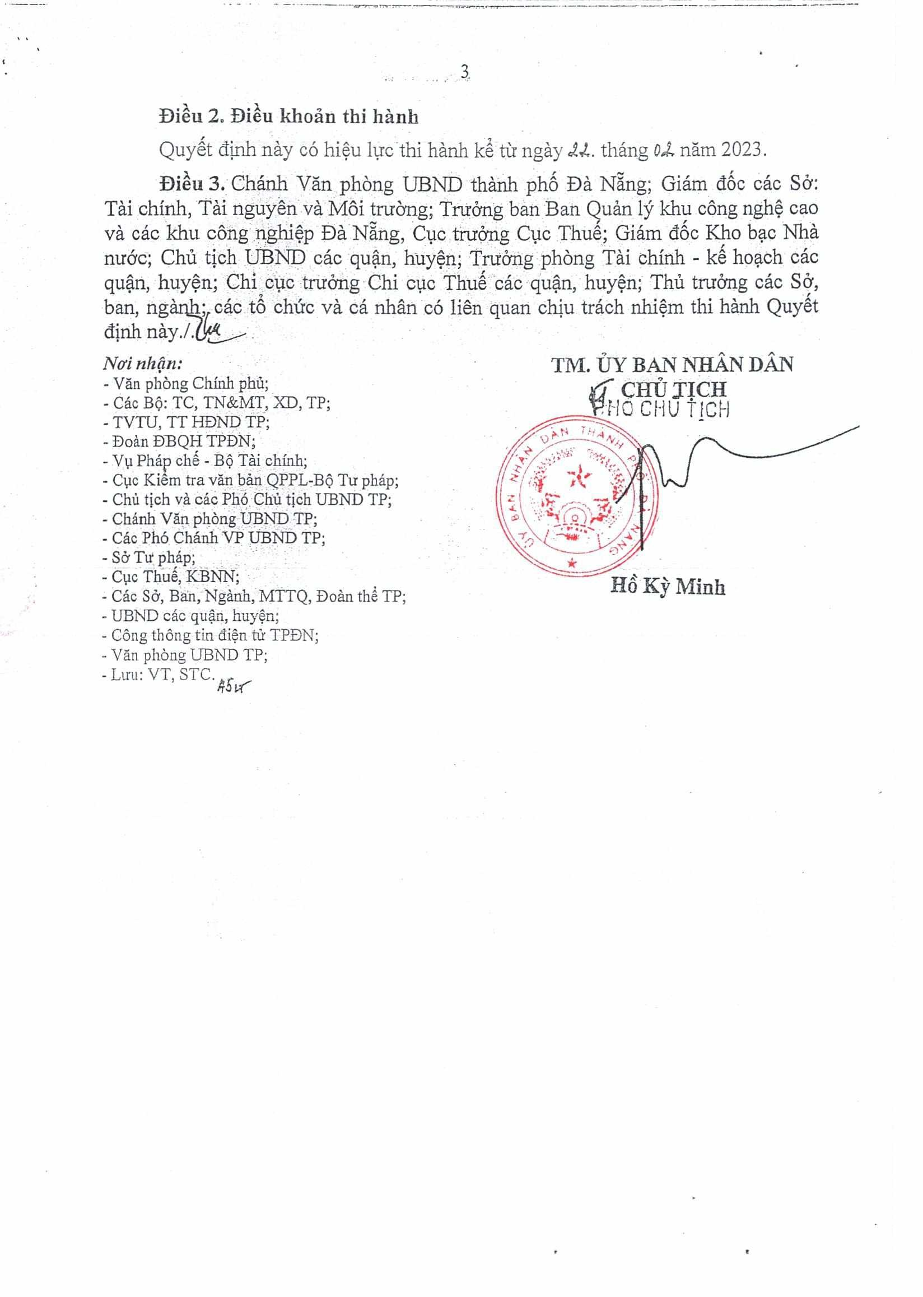
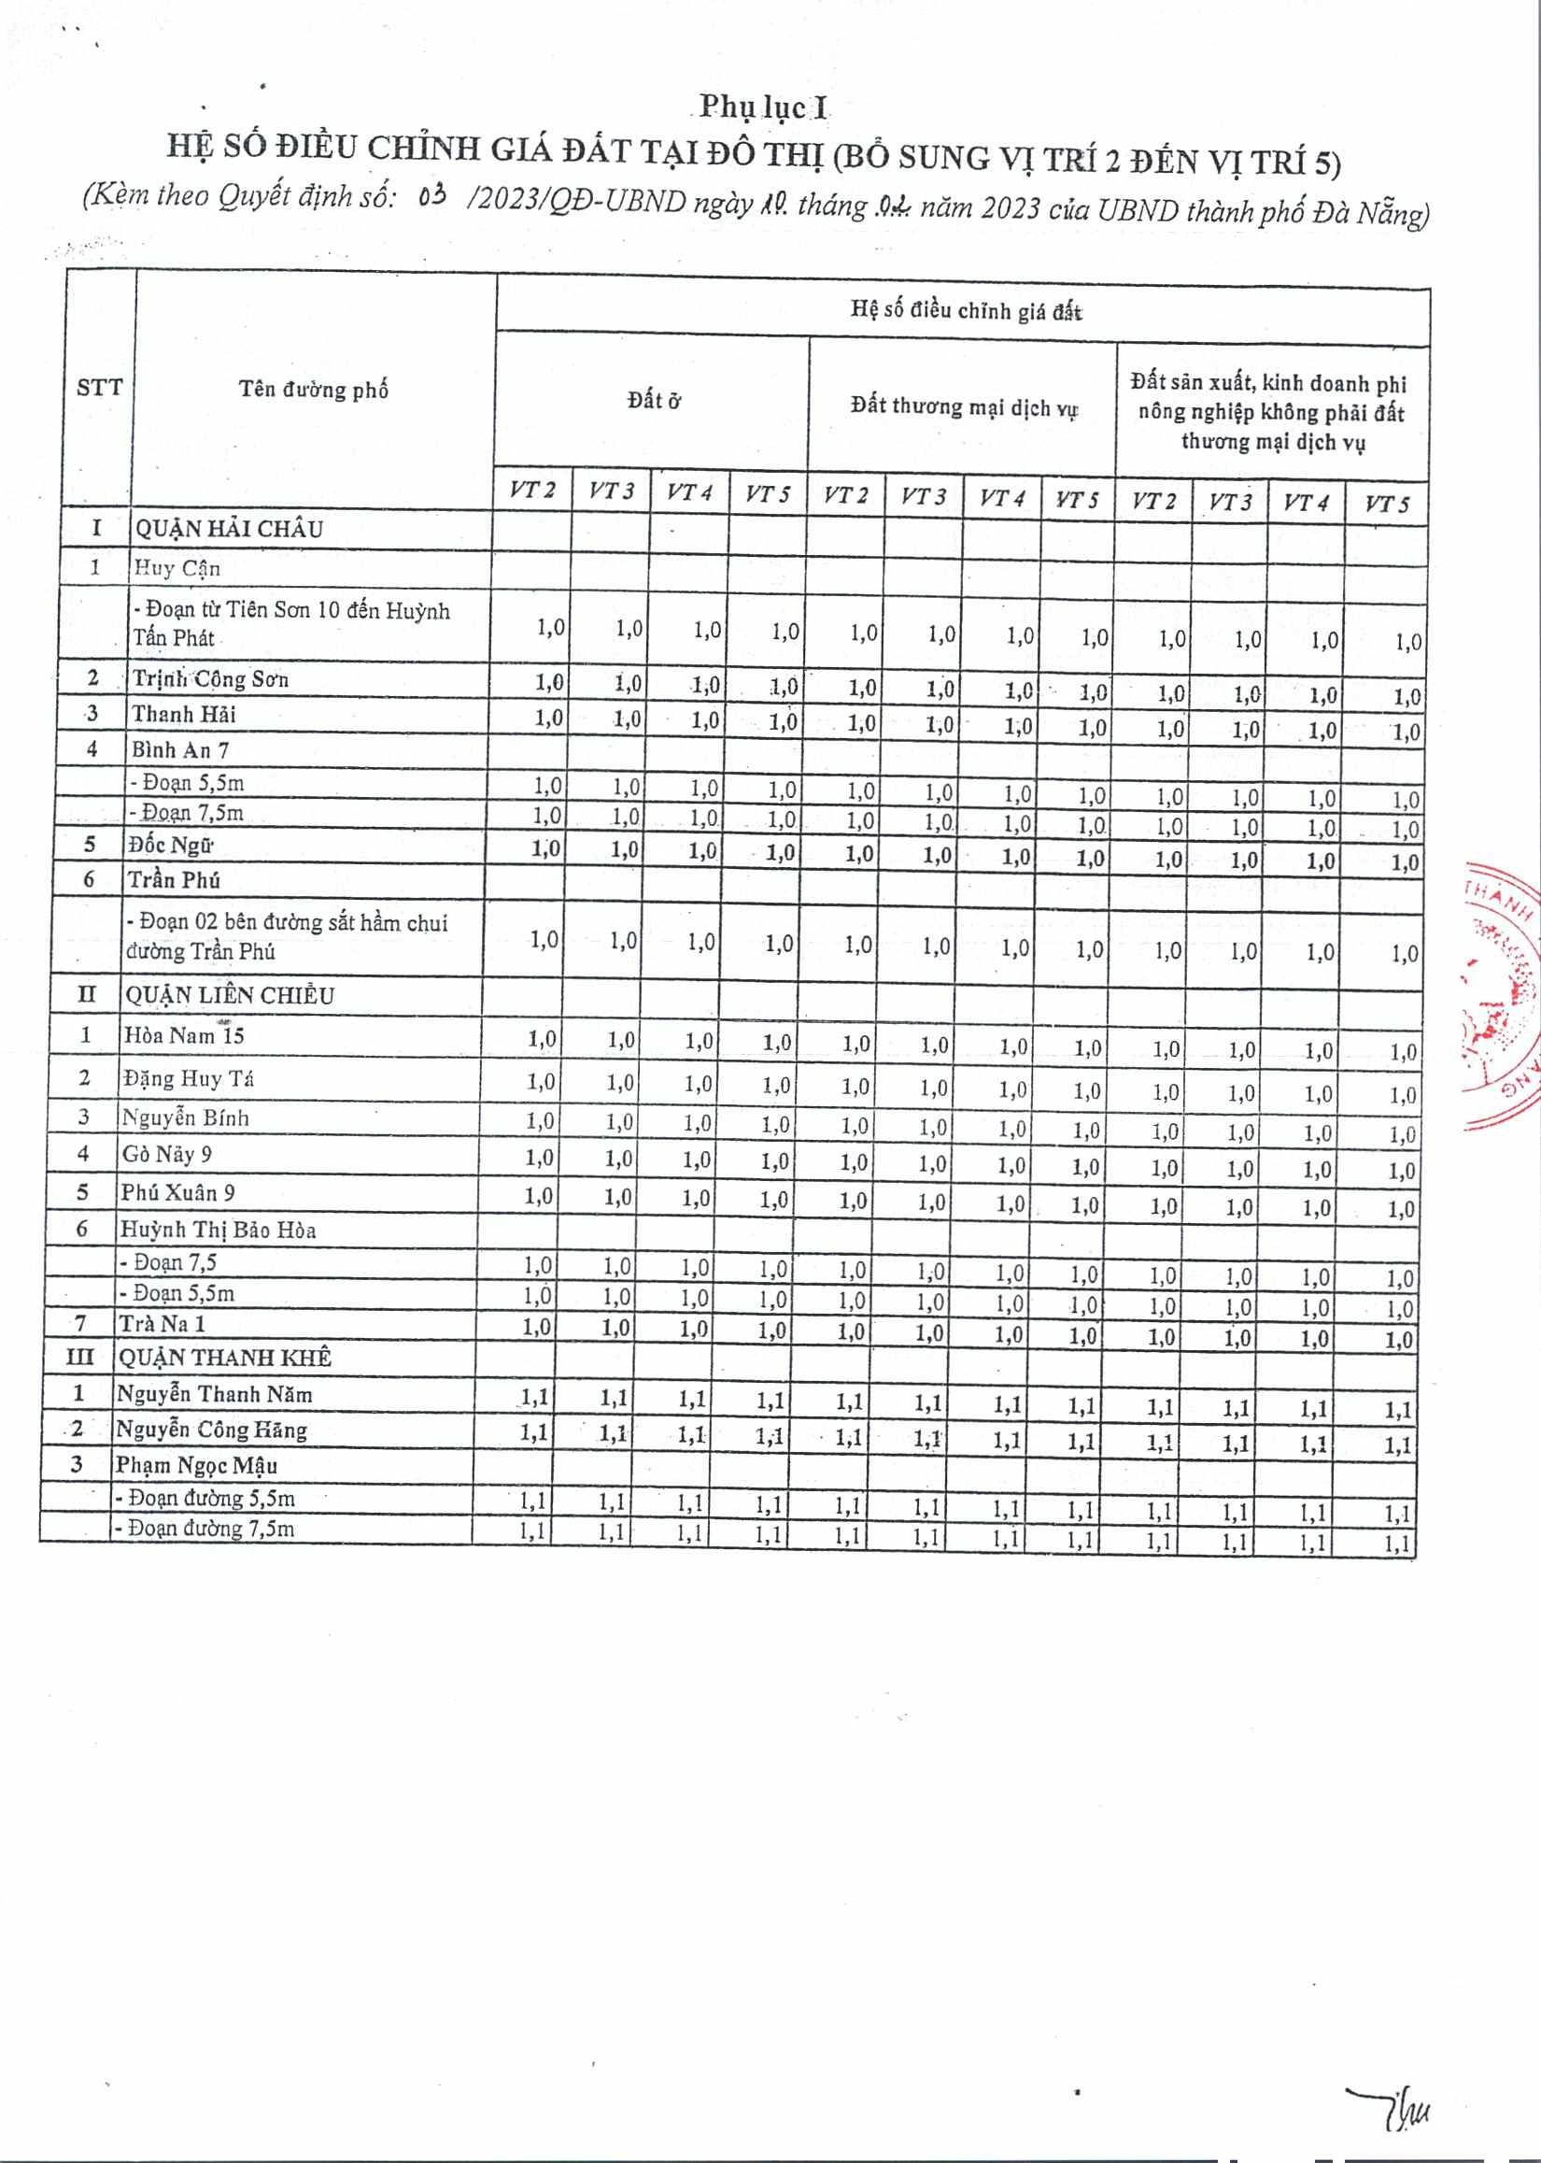
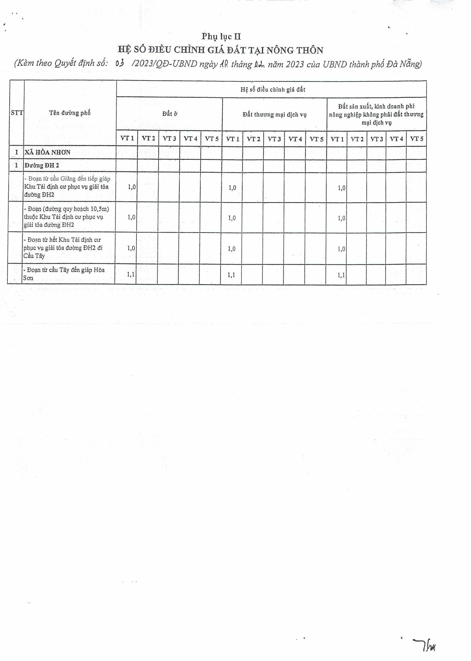
(
Ten thrrng ph6
£
.1
£
Hç so
dLeu
chinh giá
at
Dit
thtrcyng mal
dlch
vi
Dt san xut, klnh doanh phi
nông nghip không phãi dAt thu'o'ng
mai
djch vi
VT 1
VT 2
VT 3
VT 4
VT
5

VT 1
VT 2
VT 3
VT 4
VT 5
VT I
VT 2
VT 3
VT 4
VT S
I
1

Dtr&ngDH2
Don tr cu Giang dn ti8p giáp
-
KhuTái djxth ctr phicvv giài tôa
duàng DH2
1
,0
1
,0
1
,0
•
Don (throng quyhoach 10,5m)
thucKhuTãdin]1ctxph11cvl,1
giãi toa
tOng DH2
1
,0
1
,0
,0
1
•
Don tr h& Khu Tái djnh cit
phiic vi giãi tóa thrOng
H2 di
CuTy
1
,0
1
,0
1
,0
-
DoantrciuTAydngiápHoa
Son
11

11

11

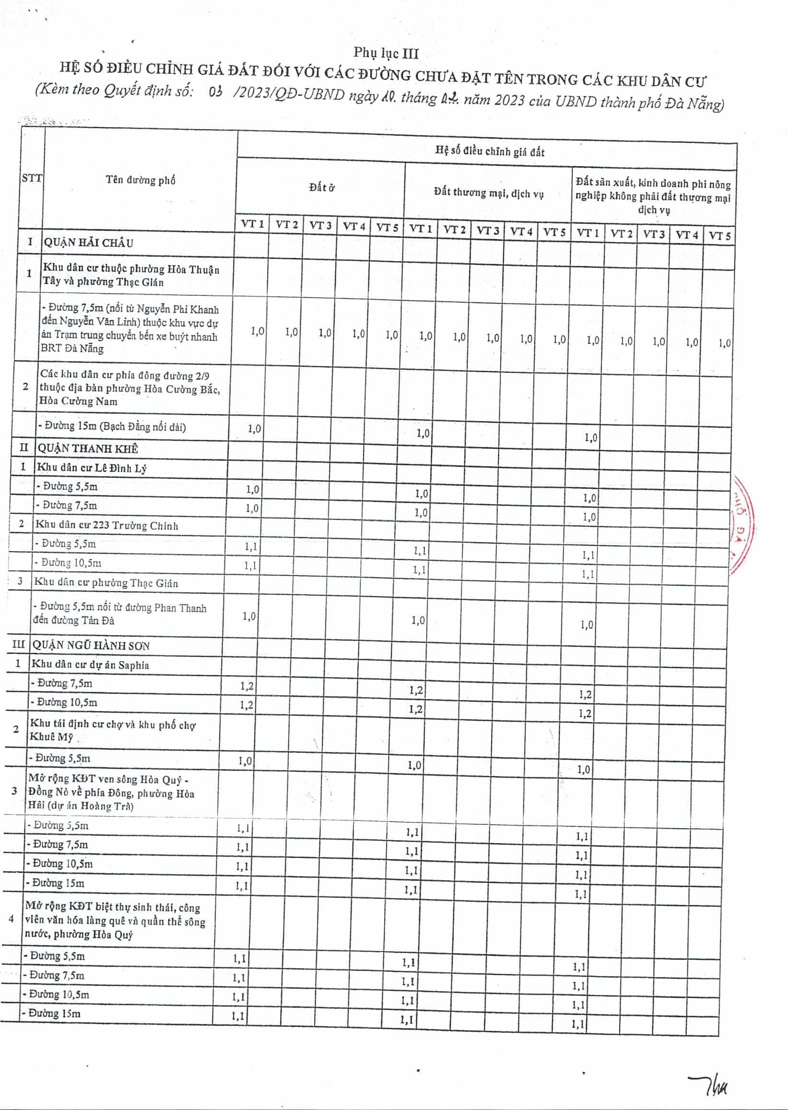
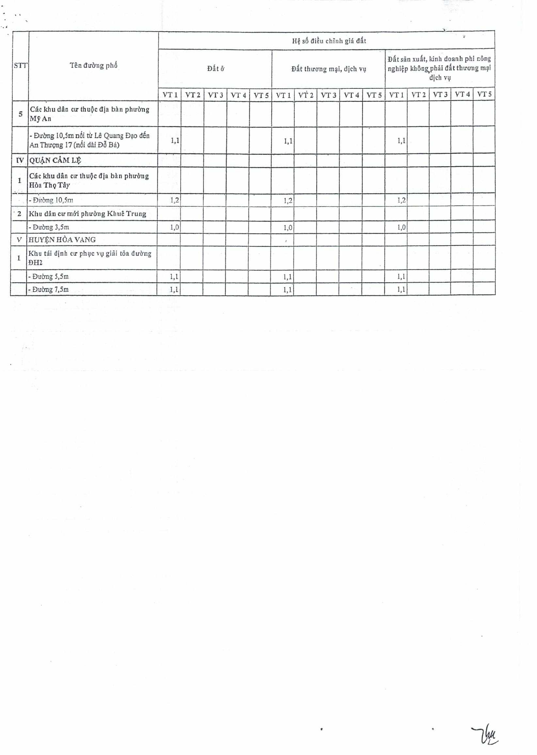
SiT
Ten
irerng ph6
h
.1
£
H
Dt &
djch vy
VT1
VT2
VT3
VT4
YT5
VT1
VT2
VT3
VT4
VT5
VT1
VTZ
YF3
VT4
VT5
CAc khu dAn cr thuc dja bàn phirOng
MyAn
-
Dithng E0,5nin6i tr LC Quang Dao
den
An ThsrQng 17 (nói dAi
Ba)
11

11

WQTJ.NCAML

1
CAc khu dAn cir thuc
dia
bàn phlr&ng
HOa ThçTAy
Dirng 10,5ni
-
1
,2
1
,2
1
,2
2

Xhu dan cLrnlOi phu0ng Khuê Trung
-
Diôiig 3,5m
1
,0
1
,0
1
,0
V
HUYNHO-tVANG
-

Kiss tA dnh cit phyc v
giAl tOa dsr?rng
DHZ
-
Dirang
5
,5ni
1
,
1
•_

1
,1
1
,1
-
FJixóng7,5m
1
,1
1
,1
1
,1
'th

